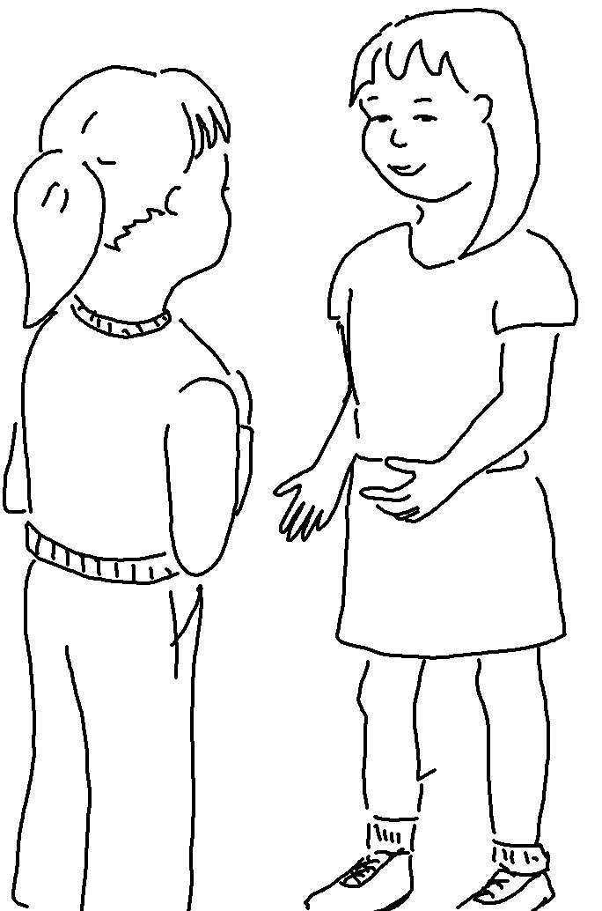
Then the King will say to those on his right, "Come, you who are
_ _ _ _ _ _ _ by my Father… I was _ _ _ _ _ _, and you fed me. I was thirsty, and you gave me a _ _ _ _ _."
Matthew 25:34, 35_{NLT}

